 Assignment 3

Name : Aditya Latke
PRN : 1262252462
DIV : 1

Lab Assignment No. : 03

PROBLEM STATEMENT:
Write a program in C to generate multiplication tables for a given number.

OBJECTIVES:
• To understand the use of looping statements in C.
To generate multiplication tables using loops.
To improve program logic and execution flow understanding.

THEORY:

1. Syntax for for loop example program:

Syntax:
for(initialization; condition; increment/decrement)
{
// statements
}

Example
#include <stdio.h>

int main()
{
int i;
for(i = 1; i <= 5; i++)
{
printf("%d\n", i);
}
return 0;
}

2. Syntax for while loop example program:
Syntax:
while(condition)
{
// statements
}

Example:
#include <stdio.h>

int main()
{
int i = 1;
while(i <= 5)
{
printf("%d\n", i);
i++;
}
return 0;
}

3. Syntax for do while loop example program:
Syntax:
do
{
// statements
} while(condition);

Example:
#include <stdio.h>

int main()
{
int i = 1;
do
{
printf("%d\n", i);
i++;
} while(i <= 5);

return 0;
}

ALGORITHM:

Step 1: Start

Step 2: Declare integer variables num and i

Step 3: Display message “Enter a number”

Step 4: Read the value of num

Step 5: Initialize i = 1

Step 6: Check condition i ≤ 10
- If true, go to Step 7
- If false, go to Step 10

Step 7: Calculate result = num × i

Step 8: Display num × i = result

Step 9: Increment i by 1 and go back to Step 6

Step 10: Stop

Program (Multiplication table):
#include <stdio.h>

int main()
{
int num, i;

printf("Enter a number: ");
scanf("%d", &num);

for(i = 1; i <= 10; i++)
{
printf("%d x %d = %d\n", num, i, num * i);
}

return 0;
}

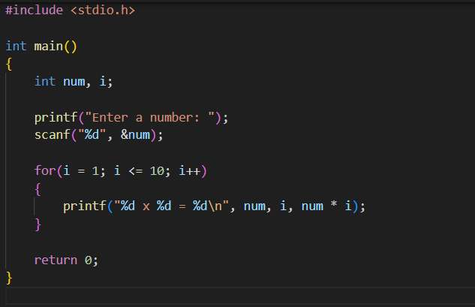

PLATFORM:
Linux

INPUT:
Choice of operation and two numbers:
55

OUTPUT:
Displays the result of the selected arithmetic operation:
Enter a number: 55 x 1 = 55
55 x 2 = 110
55 x 3 = 165
55 x 4 = 220
55 x 5 = 275
55 x 6 = 330
55 x 7 = 385
55 x 8 = 440
55 x 9 = 495
55 x 10 = 550
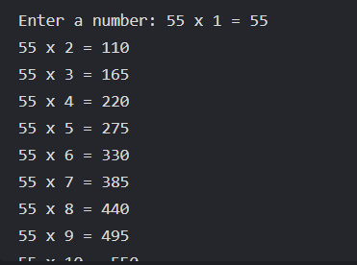

CONCLUSION:
Thus, the menu driven program in C successfully performs basic arithmetic operations
using switch–case statements.

FAQs:
1. Which loop is best suited for generating multiplication tables?
2. What is the role of loop initialization?
3. Difference between for loop, while loop and do while loop?
4. Can a do–while loop be used to generate multiplication tables? Explain.
5. Why is the do–while loop called an exit-controlled loop?

